Review Test 1

1. (calculator not allowed) The $\lim_{h→0}\frac{tan3\left(x+h\right)-tan3x}{h}$ is
   1. 0
 $3\sec^{2}\left(3x\right)$

 $\sec^{2}\left(3x\right)$

 $3cot\left(3x\right)$

2. nonexistent

$f\left(x\right)=\left\{\begin{matrix}x+2b\text{ if }x≤2 \\ ax^{2}\text{ if }x>2\end{matrix}\right.$

Let $f$ be the function given above. What are all values of $a$ and $b$ for which $f$ is differentiable at ?

* 1. and
  2. and $b=\frac{1}{2}$
  3. $a=\frac{1}{4}$ and $b$ is any real number
  4. $a=b+2$, where $b$ is any real number
  5. There are no such values of $a$ and $b$

1. (calculator not allowed) If the function $f$ is continuous for all real numbers and if $f\left(x\right)=\frac{x^{2}-4}{x+2}$ when $x≠-2$, then $f\left(-2\right)=$
   1. -4
   2. -2
   3. -1
   4. 0
   5. 2
2. (calculator not allowed) $\lim_{x→e}\frac{lnx-1}{x-e}$ is
 $\frac{1}{e}$

  1. 1
 $e$

  2. Nonexistent
3. (calculator not allowed) $\lim_{x→0}\frac{7x-sinx}{x^{2}+sin\left(3x\right)}=$
   1. 6
   2. 2
   3. 1
   4. 0
4. (calculator not allowed) $f\left(x\right)=\left\{\begin{matrix}x\text{ for }x<2 \\ 3\text{ for }x≥2\end{matrix}\right.$ If $f$ is the function defined above, then $\int_{-1}^{4}{f}\left(x\right)dx$ is
 $\frac{9}{2}$

 $\frac{15}{2}$

 $\frac{17}{2}$

1. undefined
5. (calculator not allowed)
$$\int_{0}^{3}{\frac{x^{2}+4x+5}{x+3}}dx=$$

$\frac{84}{63}$

$3+2ln2$

$\frac{15}{2}+2ln2$

$\frac{15}{2}+2ln3$

6. calculator not allowed) $∫e^{x}cos\left(e^{x}+1\right)dx=$
$sin\left(e^{x}+1\right)+C$

$e^{x}sin\left(e^{x}+1\right)+C$

$e^{x}sin\left(e^{x}+x\right)+C$

$\frac{1}{2}\cos^{2}\left(e^{x}+1\right)+C$

7. (calculator not allowed) $∫\frac{x}{x^{2}-4}dx=$
$\frac{-1}{4{\left(x^{2}-4\right)}^{2}}+C$

$\frac{1}{2\left(x^{2}-4\right)}+C$

$\frac{1}{2}ln\left|x^{2}-4\right|+C$

$2ln\left|x^{2}-4\right|+C$

$\frac{1}{2}arctan\left(\frac{x}{2}\right)+C$

8. (calculator allowed) The function $g$ is continuous on the closed interval $\left[2,10\right]$. If $\int_{2}^{10}{g}\left(x\right)dx=63$ and $\int_{10}^{5}{\frac{1}{2}}g\left(x\right)dx=-16$, then $\int_{2}^{5}{2}g\left(x\right)dx=$
   1. 31
   2. 62
   3. 95
   4. 190
9. (calculator not allowed) Using the substitution $u=x^{2}-3,\int_{-1}^{4}{x}{\left(x^{2}-3\right)}^{5}dx$ is equal to which of the following?
$2\int_{-2}^{13}{u^{5}}du$

$\int_{-2}^{13}{u^{5}}du$

$\frac{1}{2}\int_{-2}^{13}{u^{5}}du$

$2\int_{-2}^{13}{u^{5}}du$

$\int_{-1}^{4}{u^{5}}du$

10. (calculator not allowed)
$$∫\frac{7x}{\left(2x-3\right)\left(x+2\right)}dx$$

$\frac{3}{2}ln\left|2x-3\right|+2ln\left|x+2\right|+C$

$3ln\left|2x-3\right|+2ln\left|x+2\right|+C$

$3ln\left|2x-3\right|-2ln\left|x+2\right|+C$

$-\frac{6}{{\left(2x-3\right)}^{2}}-\frac{2}{{\left(x+2\right)}^{2}}+C$

11. (calculator not allowed)
$$∫\frac{1}{x^{2}-10x+34}dx=$$

$ln\left|x^{2}-10x+34\right|+C$

$arctan\left(\frac{x-5}{9}\right)+C$

$\frac{1}{3}arctan\left(\frac{x-5}{3}\right)+C$

$3arctan\left(\frac{x-5}{3}\right)+C$

12. 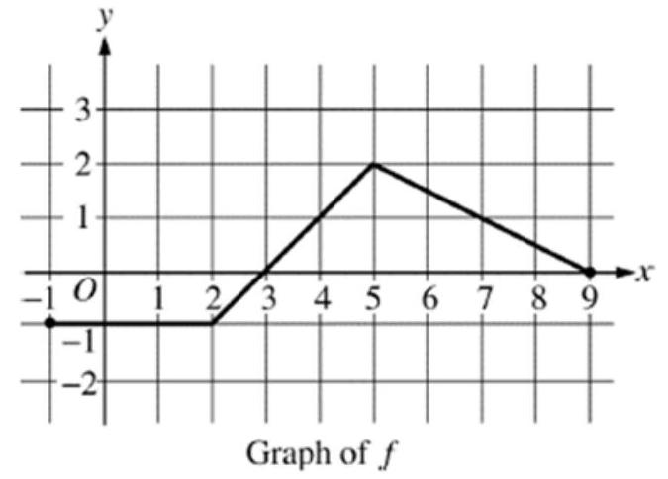(calculator not allowed) The graph of a piecewise linear function $f$ is given. What is the value of $\int_{-1}^{9}{\left(3f\left(x\right)+2\right)}dx$?
    1. 7.5
    2. 9.5
    3. 27.5
    4. 47
    5. 48.5
13. (calculator not allowed) $\int_{1}^{∞}{x}e^{-x^{2}}dx$ is
 $-\frac{1}{e}$

 $\frac{1}{2e}$

 $\frac{1}{e}$

 $\frac{2}{e}$

1. divergent